Cleaning Service Company

1. Software requirements

IDE: - Visual Studio Code

XAMPP : - for local server

Composer

PHP

NPM

1. Command for execute program: -

Php artisan serve

1. Import sql file
2. URL : localhost/phpmyadmin

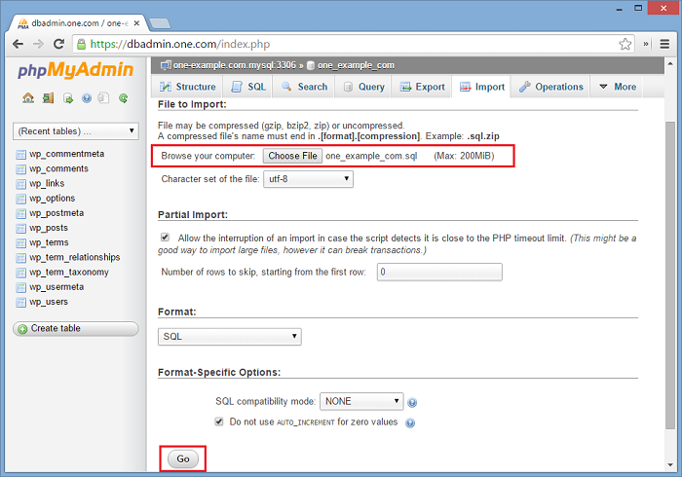

1. Email Setup for admin
2. Go To .env file and update

MAIL_DRIVER=smtp

MAIL_HOST=smtp.googlemail.com

MAIL_PORT=465

MAIL_USERNAME= your email

MAIL_PASSWORD=your password (generate app password from gmail)

MAIL_ENCRYPTION=ssl

MAIL_FROM_ADDRESS = your email

MAIL_FROM_NAME="${APP_NAME}"